Measurement Scale
# Source: AI Source: Provided by: [Data Path: Persons Table -> ID Column: 1, Name_En Column: Motasem Essam] -> From: [ChatGPT] on [7/17/2026]
A Measurement Scale is a system or framework used to assign values, labels, or numbers to the characteristics of objects, events, or quantities according to defined rules. It determines how measurements are represented, compared, and interpreted, and it influences which mathematical and statistical operations are valid.
Measurement scales are fundamental in mathematics, statistics, science, engineering, psychology, economics, medicine, and social sciences.

Definition
# Source: AI Source: Provided by: [Data Path: Persons Table -> ID Column: 1, Name_En Column: Motasem Essam] -> From: [ChatGPT] on [7/17/2026]
A Measurement Scale is a structured method of representing observations or measurements using numbers or labels according to specific rules.

Purpose
# Source: AI Source: Provided by: [Data Path: Persons Table -> ID Column: 1, Name_En Column: Motasem Essam] -> From: [ChatGPT] on [7/17/2026]
Measurement scales are used to:
- Classify observations.
- Compare measurements.
- Quantify physical or abstract properties.
- Support mathematical and statistical analysis.
- Standardize data collection and interpretation.

Characteristics
# Source: AI Source: Provided by: [Data Path: Persons Table -> ID Column: 1, Name_En Column: Motasem Essam] -> From: [ChatGPT] on [7/17/2026]
Measurement scales:
- Define how values are assigned.
- Determine relationships between values.
- Specify allowable mathematical operations.
- Influence statistical analysis.
- May represent either qualitative or quantitative information.

Types of Measurement Scales
# Source: AI Source: Provided by: [Data Path: Persons Table -> ID Column: 1, Name_En Column: Motasem Essam] -> From: [ChatGPT] on [7/17/2026]
The four classical levels of measurement are:
- Nominal Scale
- Ordinal Scale
- Interval Scale
- Ratio Scale

1. Nominal Scale
# Source: AI Source: Provided by: [Data Path: Persons Table -> ID Column: 1, Name_En Column: Motasem Essam] -> From: [ChatGPT] on [7/17/2026]
The Nominal Scale classifies data into distinct categories without any order or ranking.
Characteristics
- Classification only.
- No numerical meaning.
- Categories are mutually exclusive.
- Arithmetic operations are not meaningful.
Examples
- Blood type (A, B, AB, O)
- Eye color
- Nationality
- Product category
Valid Operations
- Equality
- Inequality
- Counting frequencies

2. Ordinal Scale
# Source: AI Source: Provided by: [Data Path: Persons Table -> ID Column: 1, Name_En Column: Motasem Essam] -> From: [ChatGPT] on [7/17/2026]
The Ordinal Scale classifies data into categories with a meaningful order, but the differences between categories are not necessarily equal.
Characteristics
- Classification
- Ranking
- Unequal intervals
Examples
- Class rank
- Satisfaction ratings
- Education level
- Military rank
Valid Operations
- Comparison
- Ordering
- Median
- Percentiles

3. Interval Scale
# Source: AI Source: Provided by: [Data Path: Persons Table -> ID Column: 1, Name_En Column: Motasem Essam] -> From: [ChatGPT] on [7/17/2026]
The Interval Scale measures quantities with equal intervals but no true zero.
Characteristics
- Ordered values
- Equal spacing
- Zero is arbitrary
Examples
- Celsius temperature
- Fahrenheit temperature
- Calendar years
- IQ scores
Valid Operations
- Addition
- Subtraction
- Mean
- Standard deviation
Invalid Operation
Ratios are not meaningful.
Example:
40°C is not twice as hot as 20°C.

4. Ratio Scale
# Source: AI Source: Provided by: [Data Path: Persons Table -> ID Column: 1, Name_En Column: Motasem Essam] -> From: [ChatGPT] on [7/17/2026]
The Ratio Scale measures quantities with equal intervals and a true (absolute) zero, making all arithmetic operations meaningful.
Characteristics
- Ordered
- Equal intervals
- True zero
- Ratios are meaningful
Examples
- Length
- Mass
- Time duration
- Distance
- Speed
- Area
- Volume
- Temperature in Kelvin
Valid Operations
- Addition
- Subtraction
- Multiplication
- Division
- Ratios
Example:
10 kg is twice the mass of 5 kg.

Comparison of Measurement Scales
# Source: AI Source: Provided by: [Data Path: Persons Table -> ID Column: 1, Name_En Column: Motasem Essam] -> From: [ChatGPT] on [7/17/2026]
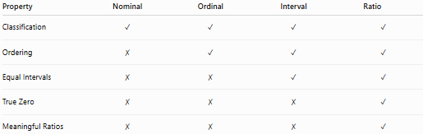
Property | Nominal | Ordinal | Interval | Ratio
Classification | ✓ | ✓ | ✓ | ✓
Ordering | ✗ | ✓ | ✓ | ✓
Equal Intervals | ✗ | ✗ | ✓ | ✓
True Zero | ✗ | ✗ | ✗ | ✓
Meaningful Ratios | ✗ | ✗ | ✗ | ✓

Measurement Scales in Physical Measurement
# Source: AI Source: Provided by: [Data Path: Persons Table -> ID Column: 1, Name_En Column: Motasem Essam] -> From: [ChatGPT] on [7/17/2026]
In science and engineering, most measurements use the Ratio Scale because physical quantities generally have a true zero.
Examples:
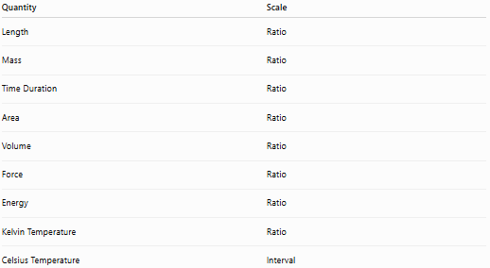
Quantity | Scale
Length | Ratio
Mass | Ratio
Time Duration | Ratio
Area | Ratio
Volume | Ratio
Force | Ratio
Energy | Ratio
Kelvin Temperature | Ratio
Celsius Temperature | Interval

Applications
# Source: AI Source: Provided by: [Data Path: Persons Table -> ID Column: 1, Name_En Column: Motasem Essam] -> From: [ChatGPT] on [7/17/2026]
Measurement scales are used in:
- Statistics
- Mathematics
- Physics
- Engineering
- Chemistry
- Biology
- Medicine
- Psychology
- Economics
- Social sciences

Advantages
# Source: AI Source: Provided by: [Data Path: Persons Table -> ID Column: 1, Name_En Column: Motasem Essam] -> From: [ChatGPT] on [7/17/2026]
Measurement scales:
- Organize data systematically.
- Determine valid mathematical operations.
- Support statistical analysis.
- Improve communication.
- Standardize measurements.

Limitations
# Source: AI Source: Provided by: [Data Path: Persons Table -> ID Column: 1, Name_En Column: Motasem Essam] -> From: [ChatGPT] on [7/17/2026]
- Choosing the wrong scale can lead to incorrect analysis.
- Some scales restrict mathematical operations.
- Qualitative scales provide less quantitative information than interval or ratio scales.

Common Mistakes
# Source: AI Source: Provided by: [Data Path: Persons Table -> ID Column: 1, Name_En Column: Motasem Essam] -> From: [ChatGPT] on [7/17/2026]
- Treating ordinal data as interval data.
- Assuming interval scales have a true zero.
- Calculating ratios using interval-scale values.
- Confusing labels with numerical quantities.
- Using inappropriate statistical methods for a given scale.

Measurement Scale vs. Measurement Unit
# Source: AI Source: Provided by: [Data Path: Persons Table -> ID Column: 1, Name_En Column: Motasem Essam] -> From: [ChatGPT] on [7/17/2026]
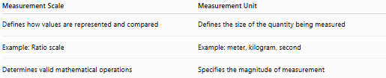
Measurement Scale | Measurement Unit
Defines how values are represented and compared | Defines the size of the quantity being measured
Example: Ratio scale | Example: meter, kilogram, second
Determines valid mathematical operations | Specifies the magnitude of measurement

Key Points
# Source: AI Source: Provided by: [Data Path: Persons Table -> ID Column: 1, Name_En Column: Motasem Essam] -> From: [ChatGPT] on [7/17/2026]
- A Measurement Scale defines how observations are represented and interpreted.
- The four classical scales are:
  - Nominal
  - Ordinal
  - Interval
  - Ratio
- Ratio Scale is the most informative because it includes:
  - Classification
  - Ordering
  - Equal intervals
  - True zero
- Most physical measurements use the Ratio Scale.
- The selected measurement scale determines which mathematical and statistical operations are valid.

Conclusion
# Source: AI Source: Provided by: [Data Path: Persons Table -> ID Column: 1, Name_En Column: Motasem Essam] -> From: [ChatGPT] on [7/17/2026]
A Measurement Scale is a structured system for representing observations or quantities according to defined rules. The four classical scales—Nominal, Ordinal, Interval, and Ratio—provide increasing levels of information and determine the mathematical and statistical operations that can be meaningfully performed. In scientific and engineering contexts, most physical quantities are measured on the Ratio Scale, while fields such as psychology and social sciences frequently use all four scales depending on the type of data being collected. Understanding measurement scales is essential for accurate measurement, data analysis, and interpretation across many disciplines.

